Synthesis and Characterization of Fe₃O₄–SiO₂-Based Ion Imprinted Polymer

Farihah Rayhana Firdausi^{1*}
¹Department of Chemistry, Faculty of Mathematics and Natural Science, Hasanuddin University, Makassar 90245, Indonesia

Corresponding Author.
*Email: fariharhfd2002@gmail.com
*Mobile WhatsApp Number Phone. +62 82195166663
The WhatsApp number used for journal management purposes will be deleted once the article is published.

ABSTRACT
This study presents the synthesis and characterization of an ion imprinted polymer (IIP) based on Fe₃O₄–SiO₂ using a surface imprinting approach. The material was designed to combine the advantages of magnetic separation, structural stability, and selective recognition properties. The synthesis involved the preparation of Fe₃O₄ nanoparticles via co-precipitation, followed by SiO₂ coating through a sol–gel process. Surface modification was carried out to introduce polymerizable groups, and polymerization was conducted using methacrylic acid (MAA) as the functional monomer, N,N′-methylenebisacrylamide (MBA) as the crosslinker, and benzoyl peroxide (BPO) as the initiator.
The structural characteristics of the synthesized material were analyzed using X-ray diffraction (XRD), Fourier transform infrared spectroscopy (FTIR), and scanning electron microscopy with energy-dispersive X-ray spectroscopy (SEM–EDS). XRD results confirmed that the crystalline structure of Fe₃O₄ was preserved after silica coating and polymerization. FTIR analysis indicated the successful formation of Si–O–Si bonds and the presence of functional groups associated with the polymer matrix. SEM images revealed irregular and aggregated particle morphology, while EDS analysis confirmed the presence of Fe, Si, O, and C elements.
These findings confirm the successful formation of a Fe₃O₄–SiO₂-based ion imprinted polymer with a well-defined core–shell structure and functional polymer layer. Furthermore, the synthesized material shows strong potential for selective adsorption and separation of lanthanum ions, making it a promising candidate for rare earth element recovery applications.

KEYWORDS: Ion imprinted polymer, Fe₃O₄–SiO₂, surface imprinting, magnetic nanocomposite, polymer synthesis

© 2026 International Conference on Multidisciplinary Engagement. All rights reserved.

- INTRODUCTION
Rare earth elements (REEs) are a group of strategic materials widely used in modern technologies, including electronics, renewable energy systems, and advanced functional materials [1]-[2]. Although REEs are relatively abundant in the Earth's crust, their extraction and separation remain challenging due to their similar chemical properties and their occurrence in low concentrations in natural resources [3]. These challenges have driven continuous research efforts to develop efficient, selective, and environmentally friendly separation methods [4]. The increasing global demand for REEs, particularly lanthanum (La³⁺), has intensified the need for advanced separation technologies [5]. Lanthanum is widely utilized in various applications such as catalysts, energy storage systems, optics, and electronic devices [6]. However, its recovery from primary and secondary resources is often hindered by the complexity of the matrices and the similarity of REE ionic radii [4]. Therefore, selective separation techniques are essential to improve recovery efficiency while minimizing environmental impact [7].
Among the available techniques, adsorption has attracted considerable attention due to its operational simplicity, cost-effectiveness, and environmental compatibility [8]. In this context, ion imprinted polymers (IIPs) have emerged as promising materials for selective ion recognition. IIPs are synthesized by polymerizing functional monomers and crosslinkers in the presence of a template ion, resulting in specific binding sites that are complementary to the target ion in terms of size, shape, and coordination environment [9]. This unique feature provides IIPs with superior selectivity compared to conventional adsorbents. Despite these advantages, conventional bulk IIP synthesis presents several limitations, including slow mass transfer, incomplete template removal, and limited accessibility of binding sites [9]. To overcome these drawbacks, surface imprinting techniques have been introduced, where the imprinted sites are formed on the surface of a supporting material [10]. This approach significantly enhances the accessibility of active sites and improves adsorption kinetics [11]. As a result, surface-imprinted polymers have gained increasing attention in recent years.
The selection of an appropriate support material is crucial for the successful fabrication of surface-imprinted polymers. Magnetic nanoparticles, particularly Fe₃O₄, have been widely explored due to their superparamagnetic properties [12]-[13], which allow rapid separation using an external magnetic field [14]. In addition, Fe₃O₄ nanoparticles exhibit low toxicity, good chemical stability, and ease of synthesis [15]. These properties make them suitable candidates as core materials for magnetic IIPs. However, bare Fe₃O₄ nanoparticles tend to aggregate and are prone to oxidation, which can negatively affect their performance. To address these issues, surface modification using silica (SiO₂) is commonly employed. The SiO₂ layer not only improves the chemical and thermal stability of the magnetic core but also provides abundant silanol (Si–OH) groups for further functionalization [16]. This modification also prevents particle agglomeration and enhances dispersibility in aqueous media.
Furthermore, the Fe₃O₄–SiO₂ core–shell structure offers a suitable platform for polymer grafting and surface imprinting. The presence of silanol groups enables effective interaction with coupling agents, facilitating the formation of a stable polymer layer [17]. This structure is advantageous for constructing well-defined imprinted sites on the surface, which can improve the overall performance of the material [18]. Compared to other support materials, Fe₃O₄–SiO₂ provides a combination of magnetic separability and chemical functionality.
In the synthesis of IIPs, the choice of monomer, crosslinker, and initiator also plays a significant role in determining the final structure of the material. Methacrylic acid (MAA) is commonly used as a functional monomer due to its ability to interact with metal ions through coordination and hydrogen bonding [19]. In this study, N,N′-methylenebisacrylamide (MBA) is employed as a crosslinker, while benzoyl peroxide (BPO) is used as a radical initiator to facilitate polymerization. The combination of these components enables the formation of a stable and crosslinked polymer network.
Based on these considerations, this study focuses on the synthesis and characterization of an ion imprinted polymer based on Fe₃O₄–SiO₂ using a surface imprinting approach. The resulting material is expected to exhibit a well-defined structure consisting of a magnetic Fe₃O₄ core, a protective SiO₂ shell, and a functional polymer layer. This study aims to synthesize and characterize a Fe₃O₄–SiO₂-based ion imprinted polymer using a surface imprinting approach, with a focus on understanding its structural properties and its potential application in selective lanthanum ion recovery.

- METHOD
The synthesis of Fe₃O₄–SiO₂-based ion imprinted polymer (IIP) was carried out through a stepwise process as illustrated in Figure 1. The synthesis involved the preparation of Fe₃O₄ nanoparticles followed by SiO₂ coating to form a core–shell structure. The Fe₃O₄–SiO₂ particles were then mixed with La³⁺ ions as the template, followed by the addition of methacrylic acid (MAA) and N,N′-methylenebisacrylamide (MBA). Polymerization is initiated using benzoyl peroxide (BPO), forming a polymer layer around the template ions. Subsequently, the template ions are removed by acid elution (HCl), resulting in the formation of specific recognition sites on the polymer surface. The final product is a Fe₃O₄–SiO₂-based IIP with a core–shell structure.

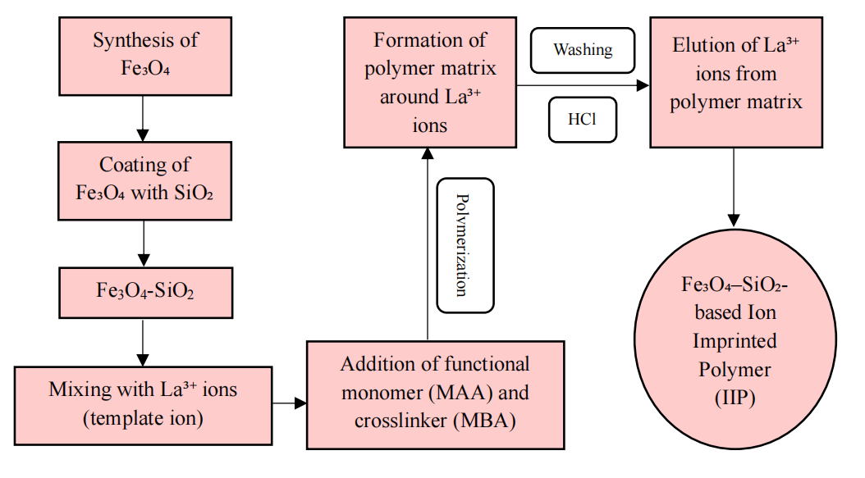
Figure 1. Schematic illustration of the synthesis of Fe₃O₄–SiO₂-based ion imprinted polymer
  - Materials and Instruments
All chemicals used in this study were of analytical grade and used without further purification. The main precursors included FeCl₃·6H₂O, FeCl₂·4H₂O, NaOH, ethanol, ammonia, tetraethyl orthosilicate (TEOS), methacrylic acid (MAA), N,N′-methylenebisacrylamide (MBA), benzoyl peroxide (BPO), N,N-dimethylformamide (DMF), and La(NO₃)₃. Deionized water was used throughout the experiments.
The synthesized materials were characterized using X-ray diffraction (XRD, Shimadzu XRD-7000L), Fourier transform infrared spectroscopy (FTIR, Shimadzu IRPrestige-21), and scanning electron microscopy coupled with energy-dispersive X-ray spectroscopy (SEM–EDS, JCM-6000Plus).

2.2 Synthesis of Fe₃O₄ Nanoparticles
Fe₃O₄ nanoparticles were synthesized using a co-precipitation method [20]. FeCl₃·6H₂O and FeCl₂·4H₂O were dissolved in deionized water under continuous stirring. The solution was heated to approximately 90 °C, followed by the dropwise addition of NaOH solution until the pH reached around 10. The resulting black precipitate was separated using an external magnet, washed several times with deionized water and ethanol, and dried at 70 °C.

2.3 Synthesis of Fe₃O₄–SiO₂
The obtained Fe₃O₄ nanoparticles were dispersed in a mixture of deionized water and isopropanol using ultrasonic treatment. Ammonia solution was then added, followed by the dropwise addition of TEOS under continuous stirring. The reaction was maintained at room temperature for several hours to allow the formation of a silica layer via the sol–gel process [17]. The Fe₃O₄–SiO₂ particles were collected, washed, and dried in a vacuum oven.

2.4 Preparation of Ion Imprinted Polymer (IIP)
2.4.1 Surface Modification
Fe₃O₄–SiO₂ particles were modified using 3-methacryloxypropyl trimethoxysilane (MAPS) in ethanol under ultrasonic dispersion [19]. The mixture was reacted at elevated temperature to introduce polymerizable functional groups onto the surface, followed by washing and drying.

2.4.2 Pre-polymerization Complex Formation
La³⁺ ions were dissolved in DMF and mixed with methacrylic acid (MAA) as the functional monomer. The solution was stirred to allow the formation of a coordination complex between La³⁺ and MAA.

2.4.3 Polymerization Process
The modified Fe₃O₄–SiO₂, MBA as crosslinker, and BPO as initiator were added into the pre-polymerization solution. The polymerization reaction was carried out under closed conditions at 60 °C for 24 h [21], resulting in the formation of a polymer layer on the surface of Fe₃O₄–SiO₂.

2.4.4 Template Removal
The obtained material was washed repeatedly with methanol, followed by elution using HCl solution to remove the template ions (La³⁺). The material was then neutralized with deionized water and dried under vacuum, yielding the Fe₃O₄–SiO₂ based ion imprinted polymer.

- RESULTS AND DISCUSSION
3.1 FTIR
The Fourier Transform Infrared (FTIR) spectrum of the synthesized Fe₃O₄–SiO₂ based material is presented in Figure 2, providing information on the functional groups and confirming the successful formation of the composite structure.
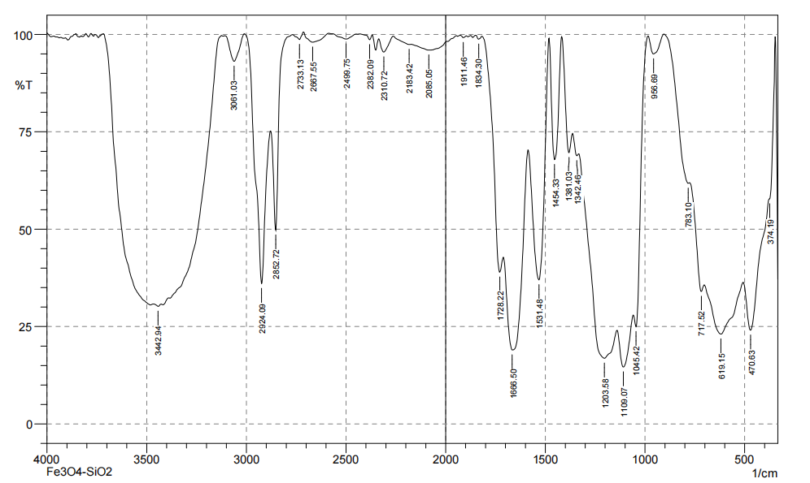
Figure 2. FTIR spectrum of Fe₃O₄–SiO₂-based ion imprinted polymer

A broad absorption band observed at around 3422 cm⁻¹ is attributed to the stretching vibration of hydroxyl groups (–OH), which can originate from adsorbed water molecules and surface silanol groups (Si–OH). The presence of these hydroxyl groups is commonly reported in silica-coated magnetic nanoparticles due to the hydrophilic nature of SiO₂ [22].
The absorption peaks at approximately 2924 cm⁻¹ and 2852 cm⁻¹ correspond to the stretching vibrations of aliphatic C–H bonds, indicating the presence of organic components associated with the polymer layer formed during the synthesis process. Similar C–H vibrations have been observed in functionalized Fe₃O₄–SiO₂ systems after surface modification [18].
A distinct absorption band appearing around 1668 cm⁻¹ is attributed to C=O stretching vibrations, while the peak near 1531 cm⁻¹ is associated with N–H bending or C–N stretching vibrations. These features indicate the formation of a polymer network, which can be attributed to the crosslinking reaction involving N,N′-methylenebisacrylamide (MBA). The presence of these functional groups confirms the successful incorporation of the polymer layer onto the Fe₃O₄–SiO₂ surface. The initiator, benzoyl peroxide (BPO), is not distinctly observed in the FTIR spectrum, which is expected due to its decomposition during the polymerization process.
The strong absorption band observed in the region of 1000–1100 cm⁻¹ (centered at approximately 1045 cm⁻¹) corresponds to the asymmetric stretching vibration of Si–O–Si bonds, which is a characteristic feature of silica. This confirms the successful coating of SiO₂ onto the Fe₃O₄ surface. Similar Si–O–Si vibrations have been widely reported in Fe₃O₄-SiO₂ core–shell structures [16].
Additionally, the absorption band observed around 956 cm⁻¹ is assigned to Si–OH stretching vibrations, further supporting the presence of silica on the material surface [16]. The peak located at approximately 783 cm⁻¹ corresponds to the symmetric stretching vibration of Si–O–Si bonds, which is another typical feature of silica networks [23].
In addition, the characteristic absorption bands observed in the low wavenumber region (around 470–580 cm⁻¹) are attributed to Fe–O stretching vibrations of magnetite, confirming the presence of the Fe₃O₄ core structure. This band is widely recognized as a fingerprint of Fe₃O₄ in magnetic nanocomposites [10].
The coexistence of Fe–O, Si–O–Si, and polymer-related functional groups in the FTIR spectrum indicates the successful formation of a Fe₃O₄–SiO₂ based ion imprinted polymer composite. These results demonstrate that the functional groups necessary for ion imprinting are present, supporting the formation of selective binding sites for La³⁺ ions.

3.2 XRD
The X-ray diffraction (XRD) pattern of the synthesized Fe₃O₄–SiO₂ based ion imprinted polymer (IIP) is presented in Figure 3. The diffractogram exhibits several distinct diffraction peaks located at approximately 2θ = 30.1°, 35.5°, 43.2°, 53.4°, 57.1°, and 62.6°. These peaks can be indexed to the (220), (311), (400), (422), (511), and (440) crystallographic planes of magnetite (Fe₃O₄), which is consistent with standard diffraction data (JCPDS No. 19-0629). The highest intensity peak at approximately 35.5° corresponds to the (311) plane, confirming that Fe₃O₄ remains the dominant crystalline phase.

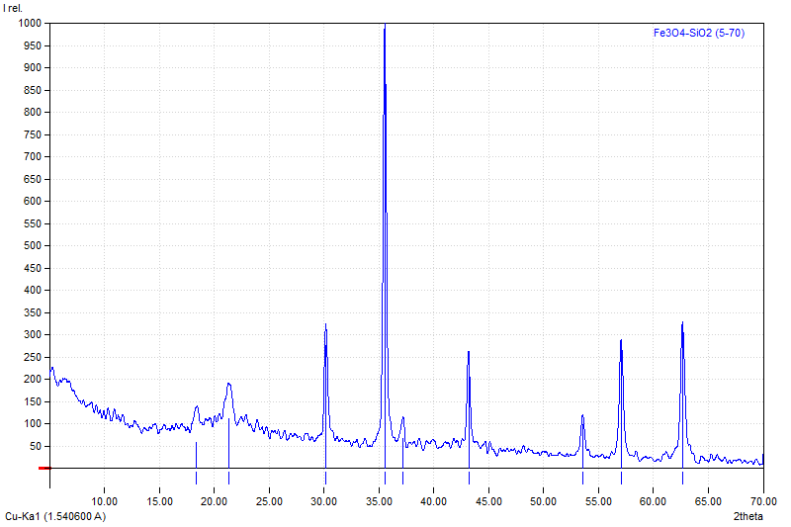
Figure 3. XRD pattern of Fe₃O₄–SiO₂ based ion imprinted polymer

The obtained diffraction peaks are in good agreement with previously reported Fe₃O₄–SiO₂ systems. Wei et al. reported similar diffraction peaks at 2θ = 30.25°, 35.59°, 43.27°, 53.63°, 57.21°, and 62.82°, corresponding to the typical crystal planes of Fe₃O₄, indicating that the crystal structure of magnetite is preserved after surface modification [10]. The close agreement between the peak positions further confirms that the crystalline phase of Fe₃O₄ in this study is consistent with those reported in the literature.
Moreover, the preservation of the main diffraction peaks after SiO₂ coating and polymer formation indicates that the crystal structure of Fe₃O₄ is not significantly affected by the synthesis process. This observation is consistent with the findings of Wei et al., who demonstrated that the majority of Fe₃O₄ characteristic peaks remained after SiO₂ coating and chitosan modification, confirming that the intrinsic structure of magnetite was maintained [10].
A similar behavior has also been reported by Wu et al., where the characteristic diffraction peaks of Fe₃O₄ were retained in Fe₃O₄-SiO₂ based core–shell structures even after further surface modification, indicating that the coating process does not alter the crystallinity of the magnetite core [24]. This consistency supports the successful formation of the Fe₃O₄–SiO₂ structure in the present study.
In addition, a broad diffraction band observed in the region of 2θ ≈ 20–25° is attributed to the presence of amorphous SiO₂, which is commonly observed in silica-coated materials. The absence of additional sharp peaks corresponding to silica or polymer components indicates that both the SiO₂ layer and the polymer matrix are predominantly amorphous in nature.
No additional crystalline impurity peaks are detected, indicating that the synthesized material possesses good phase purity. The absence of diffraction peaks related to organic components such as MBA and BPO is expected due to their amorphous nature after polymerization.
The XRD results clearly confirm the successful formation of a Fe₃O₄–SiO₂ based ion imprinted polymer composite, in which the magnetite core retains its crystallinity while the silica and polymer layers are amorphous. These results demonstrate that the crystallinity of Fe₃O₄ is preserved, ensuring that the material retains its magnetic separation capability.

3.3 SEM
The surface morphology of the synthesized Fe₃O₄–SiO₂ based ion imprinted polymer was examined using scanning electron microscopy (SEM), as presented in Figure 4(a–b). The images reveal that the particles exhibit irregular morphology with a tendency to form agglomerated structures. This agglomeration is commonly observed in magnetic nanoparticles due to strong magnetic dipole–dipole interactions between Fe₃O₄ cores [22].
At lower magnification, the material appears as clustered aggregates with non-uniform particle distribution. This behavior is typical for Fe₃O₄-based composites, where the high surface energy and magnetic interactions promote particle aggregation. Similar morphological features have been reported in Fe₃O₄–SiO₂ nanocomposites, where agglomerated structures are frequently observed despite surface modification [23].
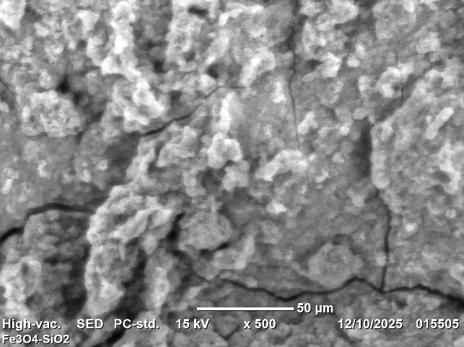
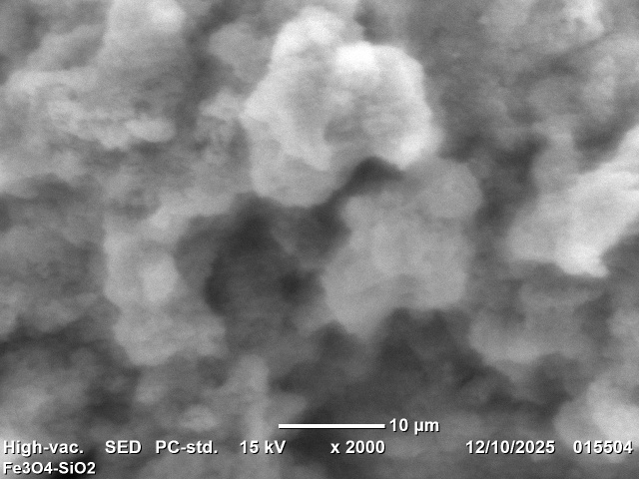
(a) (b)

Figure 4. SEM images of Fe₃O₄–SiO₂-based ion imprinted polymer at different magnifications: (a) low magnification and (b) high magnification

At higher magnification, the surface of the particles appears relatively rough and heterogeneous, which can be attributed to the presence of the silica layer and polymer coating. The formation of a SiO₂ shell is known to improve the stability of Fe₃O₄ nanoparticles while providing a surface for further functionalization, although it does not completely eliminate particle aggregation [22]. The rough surface morphology observed in this study is consistent with previous reports on Fe₃O₄-SiO₂ based materials, where the coating process leads to an increase in surface irregularity and particle size [25].
Furthermore, the composite structure suggests that Fe₃O₄ particles are embedded within a silica matrix, forming a core–shell or semi-core–shell configuration. Similar observations have been reported in Fe₃O₄-SiO₂ nanocomposites, where magnetic cores are dispersed within or coated by an amorphous silica layer, resulting in improved structural stability and surface functionality [26].
The observed morphology indicates that the synthesis process successfully produced a Fe₃O₄–SiO₂ based composite with a polymer layer, although the particles are not perfectly uniform in shape. Such morphological characteristics are commonly reported for magnetic core–shell nanocomposites and do not significantly affect the structural integrity of the material [27]. These results indicate that the rough and heterogeneous surface morphology may support interaction between the material and target ions during adsorption.

3.4 EDS
The elemental composition of the synthesized Fe₃O₄–SiO₂-based ion imprinted polymer was analyzed using energy-dispersive X-ray spectroscopy (EDS), as shown in Figure 5. The spectrum confirms the presence of Fe, Si, O, and C elements. The Fe signals correspond to the Fe₃O₄ core, while the Si and O peaks indicate the formation of the SiO₂ shell. The presence of carbon is associated with the polymer layer formed during the imprinting process.

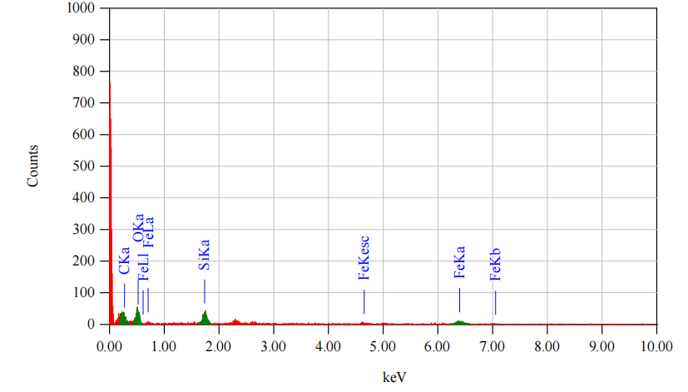
Figure 5. EDS spectrum of Fe₃O₄–SiO₂-based ion imprinted polymer
These results demonstrate that the elemental composition is consistent with the designed structure, indicating the material's suitability for selective ion recognition. No additional impurity elements were detected, indicating that the material was successfully prepared without significant contamination.

- CONCLUSION
In this study, an ion imprinted polymer (IIP) based on Fe₃O₄–SiO₂ was successfully synthesized using a surface imprinting approach. The composite material was constructed through sequential formation of a magnetic Fe₃O₄ core, a SiO₂ shell, and a polymer layer using methacrylic acid (MAA) as the functional monomer, N,N′-methylenebisacrylamide (MBA) as the crosslinker, and benzoyl peroxide (BPO) as the initiator.
The XRD analysis confirmed that the crystalline structure of Fe₃O₄ was preserved after SiO₂ coating and polymerization, indicating that the modification process did not alter the magnetic core. FTIR results verified the successful formation of Si–O–Si bonds and the presence of polymer functional groups, confirming the incorporation of both silica and polymer components. SEM observations revealed irregular and aggregated particle morphology, consistent with the formation of a polymer-coated surface. In addition, EDS analysis confirmed the presence of Fe, Si, O, and C elements, supporting the successful integration of the magnetic core, silica shell, and polymer matrix.
These results demonstrate that the Fe₃O₄–SiO₂ based IIP was successfully synthesized with the expected structural characteristics. The material exhibits a well-defined core–shell structure and functional polymer layer, indicating its potential for selective ion recognition applications. Future studies are recommended to evaluate the adsorption capacity, selectivity, and reusability of the synthesized material, particularly for the recovery of lanthanum ions from complex matrices.

ACKNOWLEDGEMENTS
The authors would like to thank Dr. Djabal Nur Basir for his valuable guidance and support throughout this research. The authors also acknowledge the Analytical Chemistry Laboratory, Faculty of Mathematics and Natural Sciences, Universitas Hasanuddin, for providing the facilities to conduct this study.

REFERENCES
[1] Y. Tao et al., “Distribution of rare earth elements (REEs) and their roles in plant growth: A review,” Environ. Pollut., vol. 298, no. October 2021, p. 118540, 2022, doi: 10.1016/j.envpol.2021.118540.
[2] T. G. Ambaye, M. Vaccari, F. D. Castro, S. Prasad, and S. Rtimi, “Emerging technologies for the recovery of rare earth elements (REEs) from the end-of-life electronic wastes: a review on progress, challenges, and perspectives,” Environ. Sci. Pollut. Res., vol. 27, no. 29, pp. 36052–36074, 2020, doi: 10.1007/s11356-020-09630-2.
[3] E. Y. Owusu-Fordjour and X. Yang, “Bioleaching of rare earth elements challenges and opportunities: A critical review,” J. Environ. Chem. Eng., vol. 11, no. 5, p. 110413, 2023, doi: 10.1016/j.jece.2023.110413.
[4] V. Mahdavi et al., “Aminoguanidine modified magnetic graphene oxide as a robust nanoadsorbent for efficient removal and extraction of chlorpyrifos residue from water,” J. Environ. Chem. Eng., vol. 9, no. 5, p. 106117, 2021, doi: 10.1016/j.jece.2021.106117.
[5] H. Zhang and Y. Gao, “Polymeric Materials for Rare Earth Elements Recovery,” Gels, vol. 9, no. 10, 2023, doi: 10.3390/gels9100775.
[6] S. B. Jadhav et al., “A critical review of lanthanum and lanthanum-based materials: synthesis, applications, and challenges,” Rare Met., 2025, doi: 10.1007/s12598-024-03204-8.
[7] P. Neira, A. Romero-Freire, M. D. Basallote, H. Qiu, A. Cobelo-García, and C. R. Cánovas, “Review of the concentration, bioaccumulation, and effects of lanthanides in marine systems,” Front. Mar. Sci., vol. 9, no. July, pp. 1–14, 2022, doi: 10.3389/fmars.2022.920405.
[8] Z. Chen, Z. Li, J. Chen, P. Kallem, F. Banat, and H. Qiu, “Recent advances in selective separation technologies of rare earth elements: a review,” J. Environ. Chem. Eng., vol. 10, no. 1, p. 107104, 2022, doi: 10.1016/j.jece.2021.107104.
[9] L. Hou et al., “Fabrication of recoverable magnetic surface ion-imprinted polymer based on graphene oxide for fast and selective removal of lead ions from aqueous solution,” Colloids Surfaces A Physicochem. Eng. Asp., vol. 625, no. June, p. 126949, 2021, doi: 10.1016/j.colsurfa.2021.126949.
[10] P. Wei, Z. Li, X. Zhao, R. Song, and Z. Zhu, “Fe3O4/SiO2/CS surface ion-imprinted polymer modified glassy carbon electrode for highly sensitivity and selectivity detection of toxic metal ions,” J. Taiwan Inst. Chem. Eng., vol. 113, pp. 107–113, 2020, doi: 10.1016/j.jtice.2020.08.035.
[11] Z. Chi, Y. Zhu, W. Liu, H. Huang, and H. Li, “Selective removal of As(III) using magnetic graphene oxide ion-imprinted polymer in porous media: Potential effect of external magnetic field,” J. Environ. Chem. Eng., vol. 9, no. 4, p. 105671, Aug. 2021, doi: 10.1016/J.JECE.2021.105671.
[12] M. Sajid, S. Shuja, H. Rong, and J. Zhang, “Size-controlled synthesis of Fe3O4 and Fe3O4@SiO2 nanoparticles and their superparamagnetic properties tailoring,” Prog. Nat. Sci. Mater. Int., vol. 33, no. 1, pp. 116–119, 2023, doi: 10.1016/j.pnsc.2022.08.003.
[13] A. Islam, H. Javed, A. Chauhan, I. Ahmad, and S. Rais, “Triethylenetetramine-Grafted Magnetite Graphene Oxide-Based Surface-Imprinted Polymer for the Adsorption of Ni(II) in Food Samples,” J. Chem. Eng. Data, vol. 66, no. 1, pp. 456–465, 2021, doi: 10.1021/acs.jced.0c00751.
[14] P. Fang et al., “Ion-imprinted mesoporous silica/magnetic graphene oxide composites functionalized with Schiff-base for selective Cu(II) capture and simultaneously being transformed as a robust heterogeneous catalyst,” Chem. Eng. J., vol. 385, no. Ii, p. 123847, 2020, doi: 10.1016/j.cej.2019.123847.
[15] M. Fernández-Ramos, J. Isasi, M. Alcolea, T. Muñoz-Ortiz, and E. Ortiz-Rivero, “New magnetic-fluorescent bifuntional (Y0.9Ln0.1VO4/Fe3O4)@SiO2 and [(Y0.9Ln0.1VO4@SiO2)/Fe3O4@SiO2] materials,” Ceram. Int., vol. 48, no. 15, pp. 22047–22058, 2022, doi: 10.1016/j.ceramint.2022.04.191.
[16] A. Khalid, R. M. Ahmed, M. Taha, and T. S. Soliman, “Fe3O4 nanoparticles and Fe3O4 @SiO2 core-shell: synthesize, structural, morphological, linear, and nonlinear optical properties,” J. Alloys Compd., vol. 947, p. 169639, 2023, doi: 10.1016/j.jallcom.2023.169639.
[17] N. C. C. Lobato, A. de M. Ferreira, P. G. Weidler, M. Franzreb, G. C. Silva, and M. B. Mansur, “Microstructure and chemical stability analysis of magnetic core coated with SILICA and functionalized with silane OTS,” Appl. Surf. Sci., vol. 505, no. June 2019, p. 144565, 2020, doi: 10.1016/j.apsusc.2019.144565.
[18] M. M. Eshaghi, M. Pourmadadi, A. Rahdar, and A. M. Diez-Pascual, “Novel Carboxymethyl Cellulose-Based Hydrogel with Core–Shell Fe3O4@SiO2 Nanoparticles for Quercetin Delivery,” Materials (Basel)., vol. 15, 2022, doi: https://doi.org/10.3390/ma15248711.
[19] M. Shi, T. Lu, X. Li, and Y. Yang, “Preparation and properties of GO-based lanthanum ion-imprinted polymer, La-IIP-MAA/Fe3O4-GO,” J. Rare Earths, vol. 40, no. 1, pp. 135–142, 2022, doi: 10.1016/j.jre.2020.12.005.
[20] F. R. Paz-Cedeno et al., “Magnetic graphene oxide as a platform for the immobilization of cellulases and xylanases: Ultrastructural characterization and assessment of lignocellulosic biomass hydrolysis,” Renew. Energy, vol. 164, pp. 491–501, 2021, doi: 10.1016/j.renene.2020.09.059.
[21] I. M. Ali, E. S. Zakaria, M. Khalil, A. El-Tantawy, and F. A. El-Saied, “Synthesis of ion-imprinted polymers based on chitosan for high selectivity of La(III), Ce(III) and Sm(III) via solid phase extraction,” J. Mol. Liq., vol. 356, p. 119058, 2022, doi: 10.1016/j.molliq.2022.119058.
[22] S. S. Alterary and A. Alkhamees, “Synthesis, surface modification, and characterization of Fe3O4@SiO2 core@shell nanostructure,” Green Process. Synth., vol. 10, no. 1, pp. 384–391, 2021, doi: https://doi.org/10.1515/gps-2021-0031.
[23] M. Yaseen et al., “Facile Synthesis of Fe3O4−SiO2 Nanocomposites for Wastewater Treatment,” Macromol. Mater. Eng., vol. 308, no. 7, pp. 1–17, 2023, doi: 10.1002/mame.202200695.
[24] F. Wu et al., “Facile synthesis of core-shell structured magnetic Fe3O4@SiO2@Au molecularly imprinted polymers for high effective extraction and determination of 4-methylmethcathinone in human urine samples,” E-Polymers, vol. 22, no. 1, pp. 488–504, 2022, doi: 10.1515/epoly-2022-0034.
[25] S. Azadi et al., “Antifungal activity of Fe3O4@SiO2/Schiff-base/Cu(II) magnetic nanoparticles against pathogenic Candida species,” Sci. Rep., vol. 14, no. 1, pp. 1–13, 2024, doi: 10.1038/s41598-024-56512-5.
[26] H. Li, H. Jin, R. Li, J. Hua, Z. Zhang, and R. Li, “Magnetic Fe3O4@SiO2 study on adsorption of methyl orange on nanoparticles,” Sci. Rep., vol. 14, no. 1, pp. 1–16, 2024, doi: 10.1038/s41598-023-50368-x.
[27] M. A. Mustafa et al., “Supercapacitor Performance of Fe3O4 and Fe3O4@SiO2-bis(aminopyridine)-Cu Hybrid Nanocomposite,” Int. J. Electrochem. Sci., vol. 17, no. 10, p. 221057, 2022, doi: 10.20964/2022.10.49.

